**SAIBR FIJI plugin: User guide**

**Overview**  
  
This plugin provides an easy-to-use, GUI-based implementation of SAIBR (Spectral Autofluorescence Image correction By Regression): a simple, platform-independent protocol for spectral autofluorescence correction. For a full description of the method, please see our paper: <https://journals.biologists.com/dev/article/149/14/dev200545/276004/SAIBR-a-simple-platform-independent-method-for>

In brief, SAIBR is designed to address the problem of autofluorescence (AF), which can be highly abundant in channels used to image green fluorophores and can significantly obscure the true fluorophore signal that one is interested in. The method takes advantage of the fact that AF typically has a much broader emission spectrum than GFP. By using a second channel with a red-shifted emission filter, we can obtain a clean readout of the level of AF in the sample, which can then be subtracted away on a pixel-by-pixel basis, e.g.:

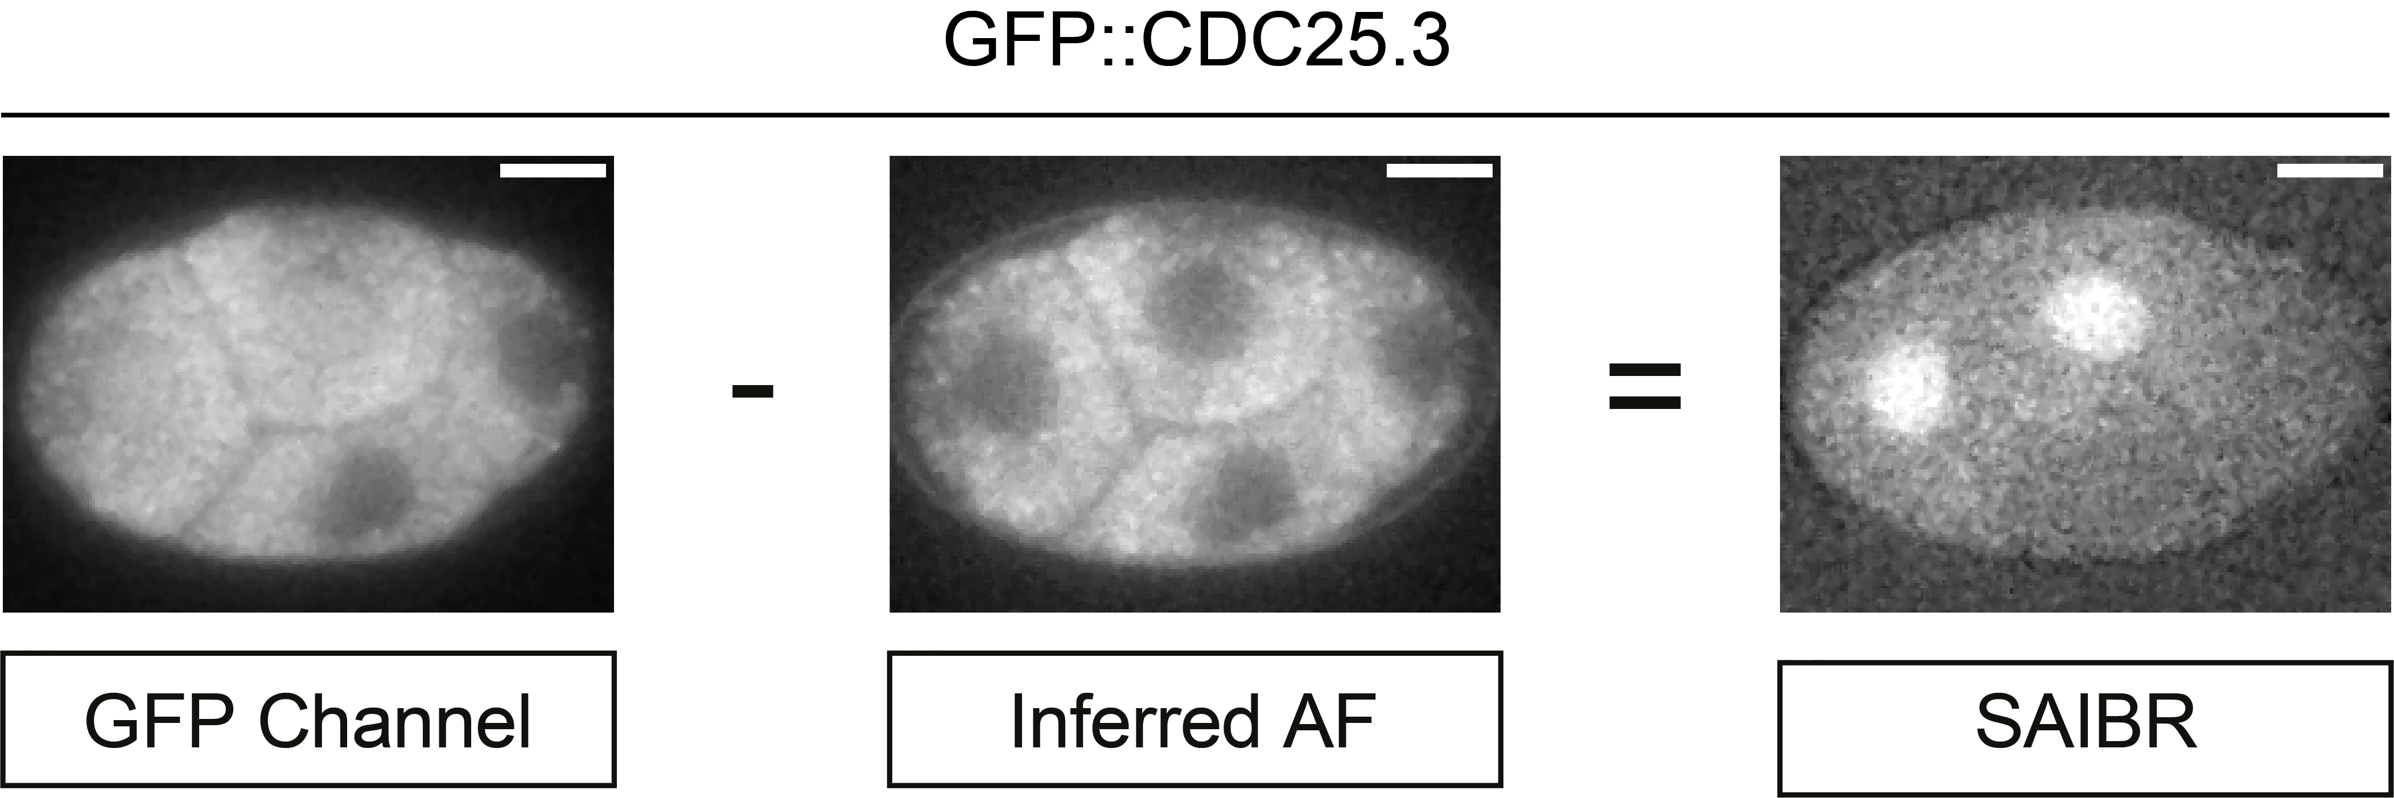

A calibration step is required to obtain the necessary inter-channel correction factors for the autofluorescence calculations. In most cases, this will involve imaging unlabelled samples (e.g. wild-type N2 *C. elegans*) using the regular GFP channel (e.g. 488nm laser, 535/50nm filter) and a red-shifted AF reporter channel (e.g. 488nm laser, 630/75nm filter). If you wish to perform AF-correction on dual colour samples containing both green and red fluorophores, calibration should instead be performed using the relevant RFP-expressing single line (to account for ‘bleedthrough’ of red fluorophore signal). In this case, you also need to include your regular RFP channel (e.g. 561nm laser, 630/75nm filter) in this procedure.

SAIBR has been validated for use in *C. elegans* embryos and tested in diverse systems, including starfish oocytes and fission yeast. The principles are general and thus should be applicable to any samples that exhibit similar broad-spectrum AF that can be captured in a wavelength-shifted emission channel. In principle, there is no need to restrict oneself to the wavelengths used in our study, which were chosen to solve the particular problem of GFP channel autofluorescence. The technique itself only requires the identification of an appropriate **‘Predictor’** channel (or channels) that can be used to infer AF in the desired fluorophore-reporting **‘Primary’** channel.

**Installation**

The plugin can be installed in one of two ways:

**Method 1 (recommended): Linking FIJI to the update site**

The recommended way to install is by linking FIJI to the update site for this plugin. This will ensure that any updates to the plugin are installed automatically. To install in this way, first open FIJI and go to *Help > Update…*. Click *Manage update sites*, then *Add update site* and enter the following details for the update site:

Name: SAIBR

URL: https://sites.imagej.net/SAIBR/

Make sure the tick box is selected and click *Close,* then click *Apply changes.* Restart FIJI when it tells you to, and when you reopen you should find *SAIBR* in the *Plugins* menu.

To download the example datasets, visit the GitHub page:

<https://github.com/goehringlab/saibr_fiji_plugin>

and download the zip file: example_datasets.zip

**Method 2: Manual installation**

To install manually, visit the GitHub page (<https://github.com/goehringlab/saibr_fiji_plugin>), and download the repository (click the green *‘Code’* button, and click *Download ZIP*). Unzip the file, then open FIJI, go to *Plugins -> Install…,* and select the .jar file found in the ‘*target’* folder of the unzipped repository. Follow the onscreen instructions, restarting FIJI when it tells you to.

NOTE: If you use this installation method, you will have to manually install updates. To do this, you will have to first delete the existing version of the plugin from FIJI’s *plugins* folder (on a Mac you can find this folder by right clicking on the FIJI icon in your Applications folder and clicking ‘*Show package conten*ts’).

**Example datasets**

A couple of example datasets are included in the GitHub repository (*example_datasets.zip*) which can be used to try out the workflow:

**Example dataset 1**: AF correction in single-colour GFP (LGL-1::GFP) *C. elegans* zygotes

* Calibration images: 3x N2 zygotes
* Test images: 3x LGL-1::GFP zygotes
* Four channels in each image:
  + Channel 1: 488nm laser, 535/50nm filter (i.e. the GFP channel. This will act as the **Primary channel** for SAIBR)
  + Channel 2: 488nm laser, 630/75nm filter (i.e. the AF channel. This will act as the **Predictor channel** for SAIBR)
  + Channel 3: 561nm laser, 630/75nm filter (i.e. the RFP channel. This can be used as a second predictor channel, but this is usually not required for single-fluorophore SAIBR)
  + Channel 4: DIC

**Example dataset 2**: AF correction in dual-fluorophore (PAR-6::GFP, mCherry::MEX-5) *C. elegans* zygotes

* Calibration images: 7x mCherry::MEX-5 zygotes
* Test images: 3x mCherry::MEX-5, PAR-6::GFP zygotes
* Four channels in each image:
  + Channel 1: 488nm laser, 535/50nm filter (i.e. the GFP channel. This will act as the **Primary channel** for SAIBR)
  + Channel 2: 488nm laser, 630/75nm filter (i.e. the AF channel. This will act as **Predictor channel 1** for SAIBR)
  + Channel 3: 561nm laser, 630/75nm filter (i.e. the RFP channel. This will act as **Predictor channel 2** for SAIBR. Note, this is required here to account for bleedthrough of mCherry::MEX-5 signal into the AF channel)
  + Channel 4: DIC
* 3x N2s are also included for comparison, but these should not be used for calibration

The complete workflow is demonstrated below using example dataset 1.

**Starting the plugin**

Open the plugin by going to *Plugins -> SAIBR*. The following window will appear:

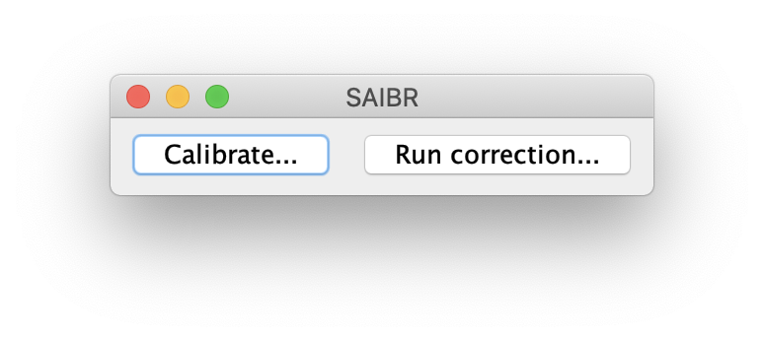

As a first step, you must calibrate the program using images of fluorophore-negative control samples. In the case of the example datasets, calibration should be performed on appropriate GFP-negative images (the untagged N2 zygotes for dataset 1 and the mCherry::MEX-5 zygotes for example dataset 2). Calibration can be done using the *Calibrate…* tool. Once you have calibrated the model, you can then perform AF-correction on fluorophore-positive samples, using the *Run correction…* tool. Both of these steps are outlined below.

**Calibration with GFP-negative control samples**

To begin calibration, open a selection of control images (3-5 images is ideal, a maximum of 10 is supported). These must be opened as multi-channel images* (one window per image, rather than separate windows for each channel). Images can be raw (i.e. direct from the microscope), as is the case with the example datasets, or can be pre-processed in any way of your choosing (e.g. background subtraction, flatness correction). This can sometimes improve performance, depending on your exact setup, but must be consistent for all images in your dataset. If images have multiple timepoints, only the currently selected timepoint will be used for calibration.

* You should ensure that the images are configured properly as multi-channel images (‘c’ slider at the bottom). In some cases, channels can be incorrectly registered as time frames. If this is the case for your images, you will need to reconfigure the images using FIJI’s *Stack to Hyperstack* tool.

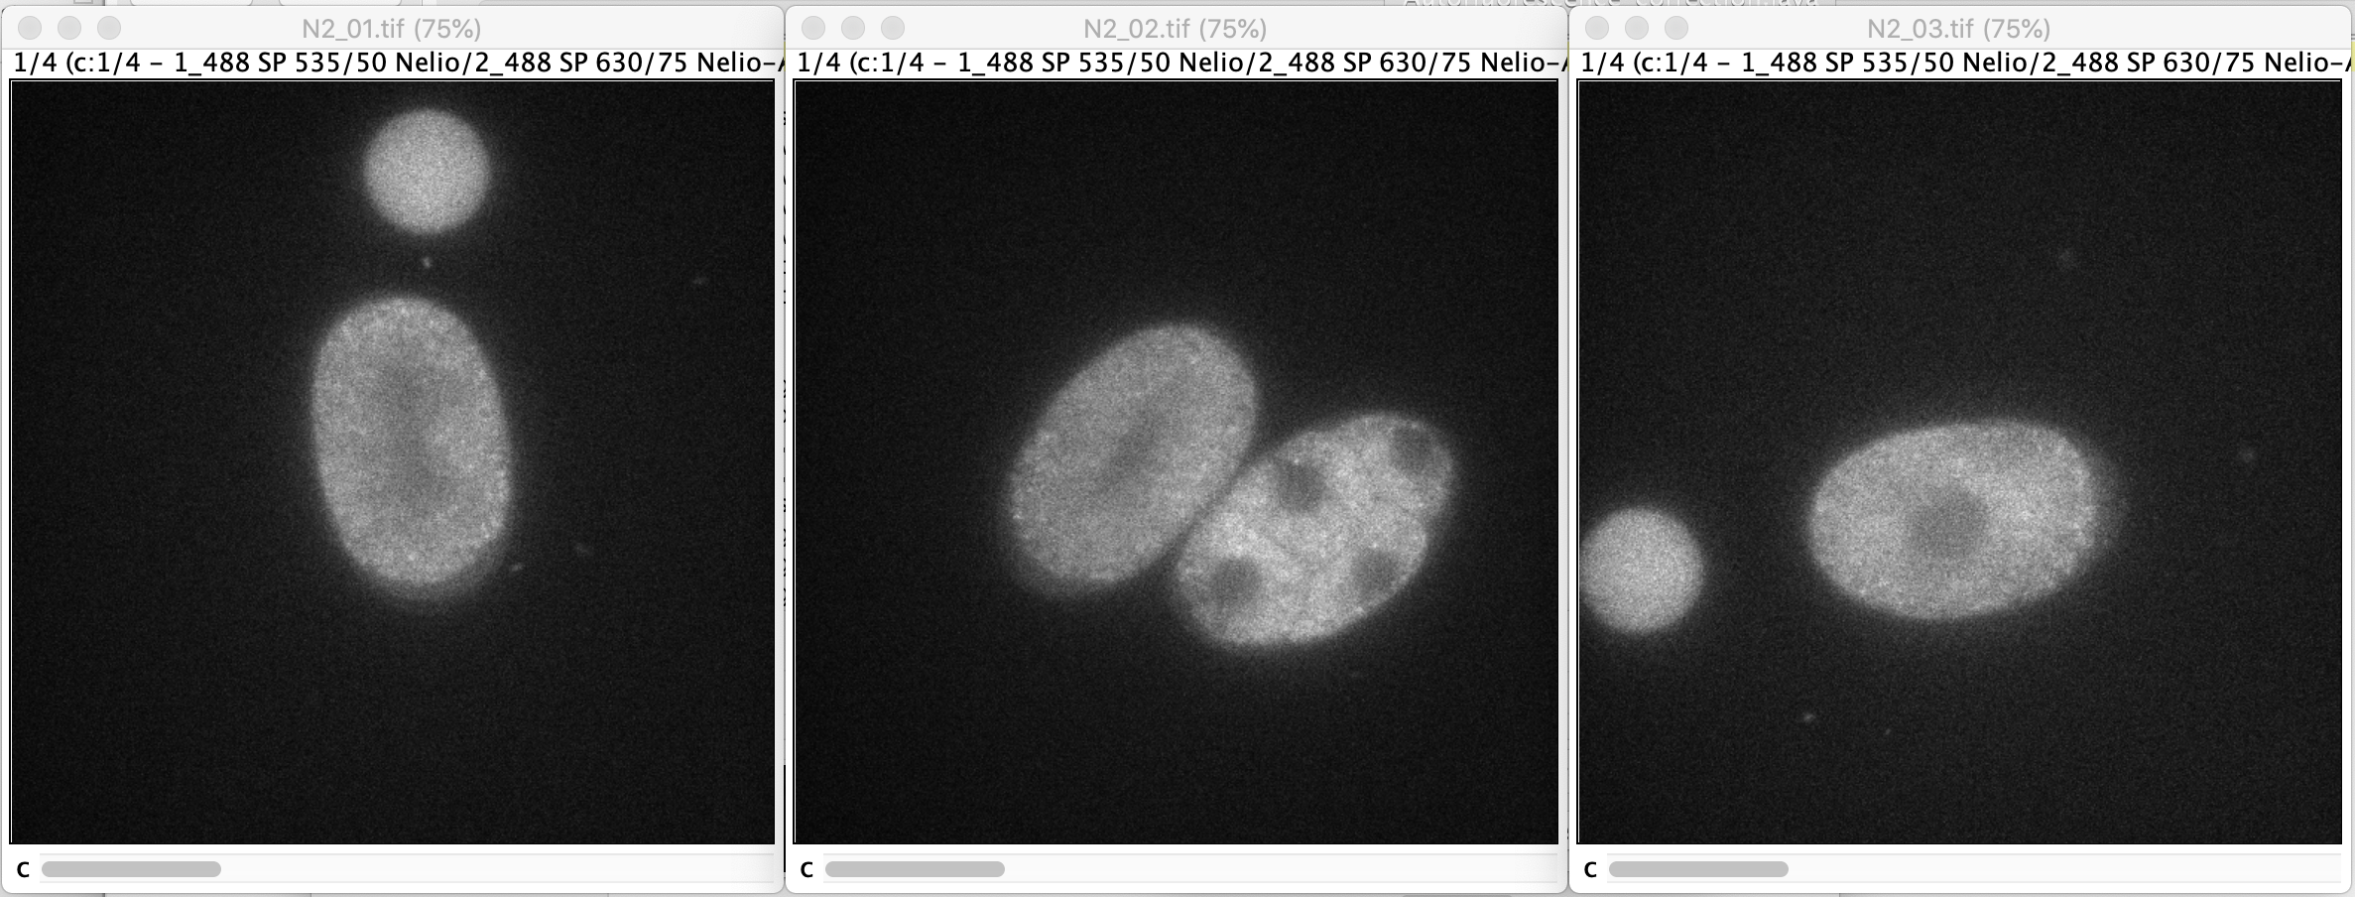

Next, click the *Calibrate…* button on the plugin window. The following window will appear:

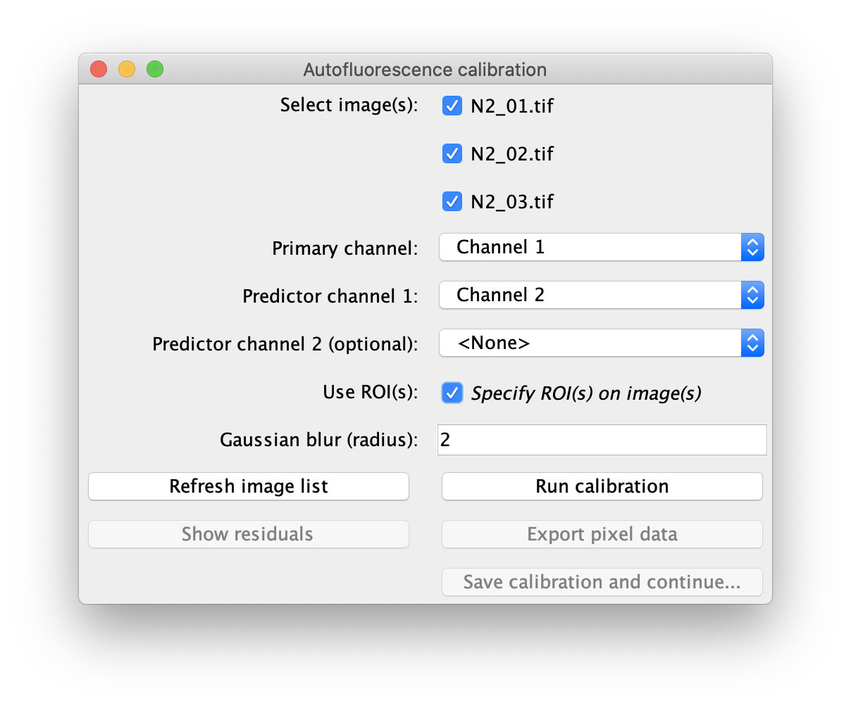

Select the images that you wish to use for calibration, and specify the following parameters:

**Primary channel:** The channel number corresponding to the **Primary** channel.

**Predictor channel 1:** The channel number corresponding to the **Predictor** channel.

**Predictor channel 2 (optional):** The channel number corresponding to a second **Predictor** channel. This is not required in this case, but should be included for SAIBR with dual-labelled samples (e.g. example dataset 2). It can also help to include this channel in some other exceptional cases, which are outlined in the main paper.

**Use ROI(s):** If selected, calibration will be confined to pixels within a user-selected ROI for each image. If unselected, the whole image will be used. You can select an ROI on each image using any of FIJI’s ROI selection tools:

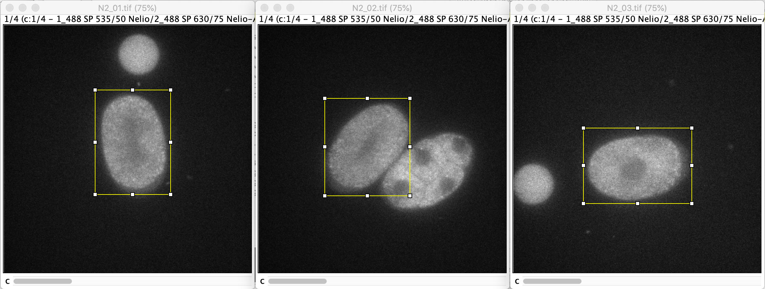

NOTE 1: It is often strongly advisable to use this feature. This is particularly useful if the sample only takes up a small part of the image, or in cases where other objects (e.g., beads) are visible in the frame, as these may throw off the calibration if included.

NOTE 2: You can select multiple separate ROIs on each image if you choose (e.g., if there are multiple cells per image). In this case, pixels from all of the ROIs will be pooled for the analysis.

**Gaussian blur (radius):** The radius of theGaussian blur to apply to the images prior to pixel-by-pixel regression. The optimal Gaussian radius will depend on the resolution and signal to noise ratio of your images, and it may be useful to try a few different values.

After setting these parameters, click *Run calibration.* In brief, this will run the following algorithm:

1. A Gaussian filter is applied to each channel of the selected images to reduce noise (note: this will not change the images on screen)
2. For each channel, all pixel values within the ROIs of the selected images are extracted and pooled
3. Linear regression (ordinary least squares) is performed on this pixel value data, capturing the relationship between pixel intensity in the **Predictor** channel(s) and AF signal in the **Primary** channel

Once this has run, a window will appear showing the results of the linear regression:

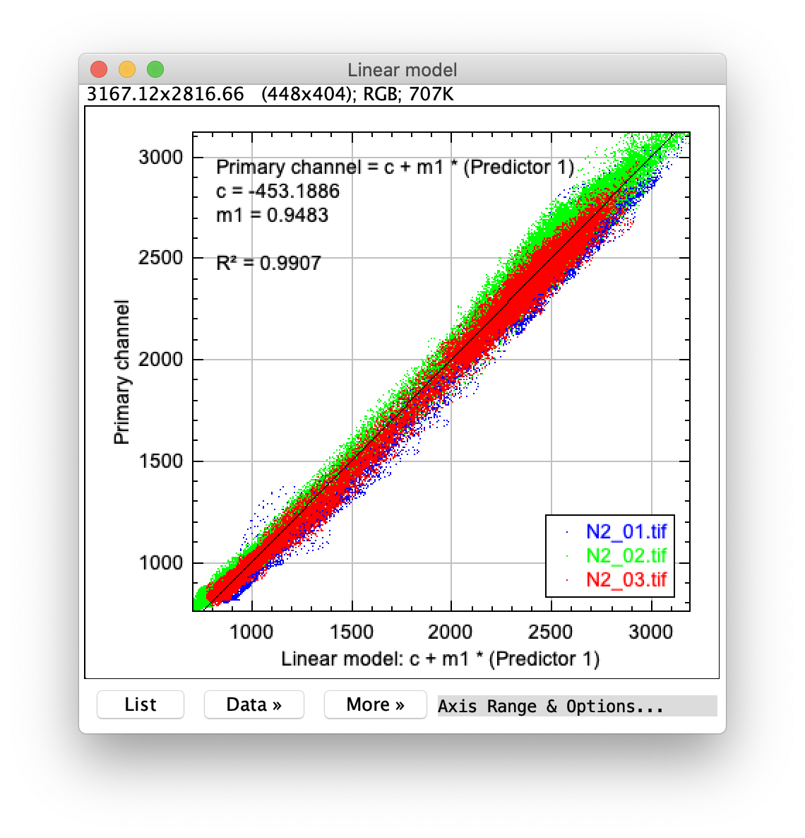

The scatter plot shows actual pixel values in the Gaussian-processed **Primary** channel (y-axis) vs. values predicted by the optimised linear model (x-axis). It’s important to study this plot carefully to make sure that it looks reasonable: a well-performing model should have a close 1:1 relationship across the entire range of pixel values for all images, and a high R-squared score (> 0.9). If the relationship looks particularly noisy, try increasing the Gaussian radius.

The parameters for the linear model (c and m1) are shown at the top-left of the figure. These will be saved by the program, but it is a good idea to note them down for your records.

Full data from the linear regression can be exported in tabular form by clicking *Export pixel data* on the main window. This may be useful should you wish to perform any further analysis.

Finally, you can assess the calibration by looking at the residuals for each training image. Click the *Show residuals* button on the main window. The core region of each residuals image should be close to zero and free of any strong spatial features:

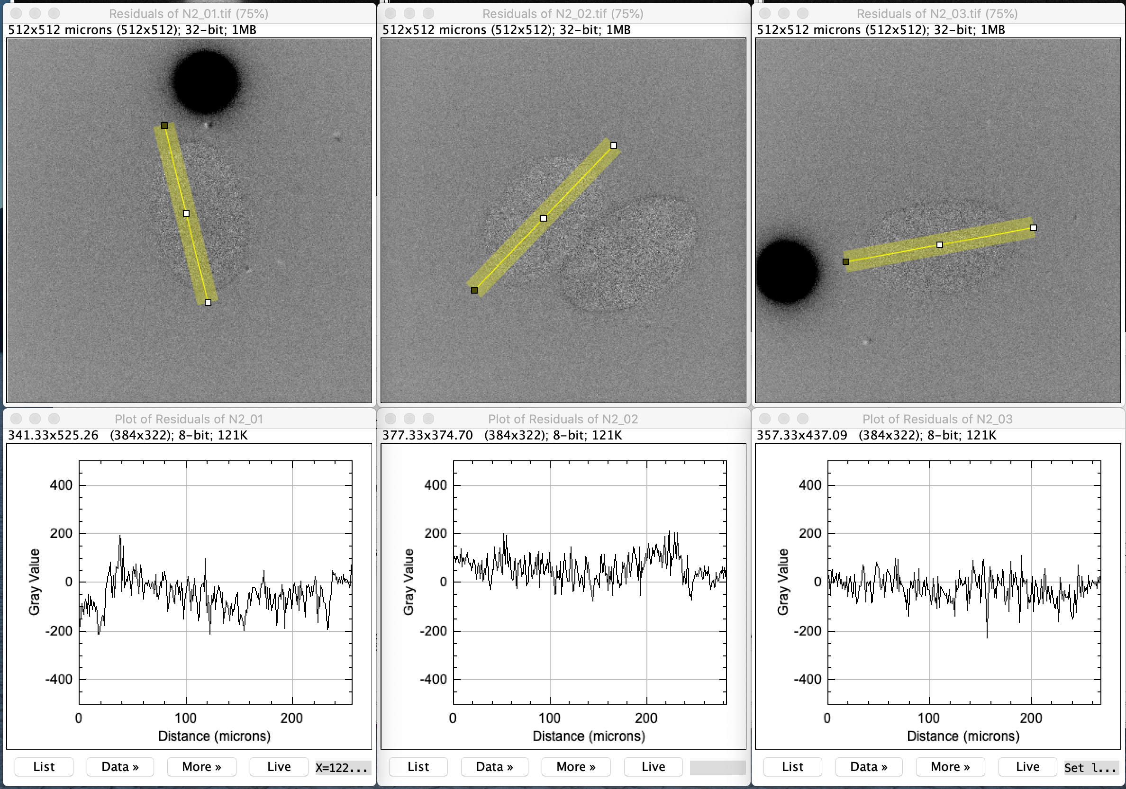

Once you are satisfied with the calibration, you can save the calibration and proceed with AF correction. Click *Save calibration and continue…* to return to the main menu.

**Autofluorescence correction**

First, open a selection of fluorophore-expressing images which you wish to correct:

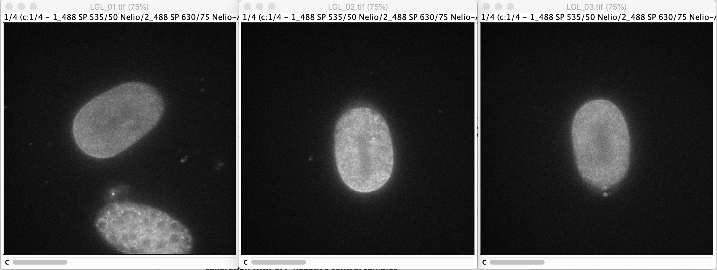

Next, click *Run correction…* from the main menu. The following window will appear:

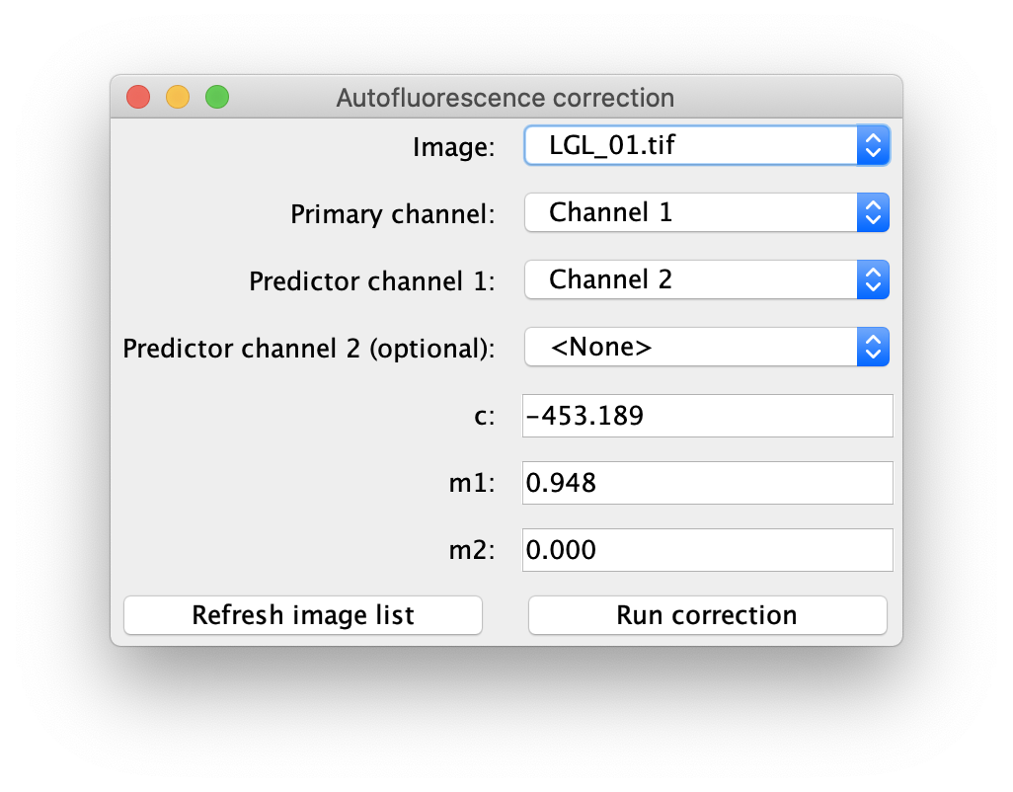

Specify an image at the top of the window. The other parameters will all be set automatically according to the calibration that has just been performed, but can also be set manually. For example, if you have quit and reopened the program since calibrating, these will have to be filled in manually (hence, it’s a good idea to note down the parameters whenever you perform calibration!).

Click *Run correction,* which will perform the following operations:

1. The AF contribution in the **Primary** channel is predicted as a linear function of the **Predictor** channel(s), based on the calibration previously obtained.
2. This inferred AF is subtracted from the **Primary** channel, giving a corrected image which represents the true (autofluorescence-free) fluorophore signal.

The resulting AF-corrected image will appear onscreen. This step can then be repeated for all of the images in the dataset:

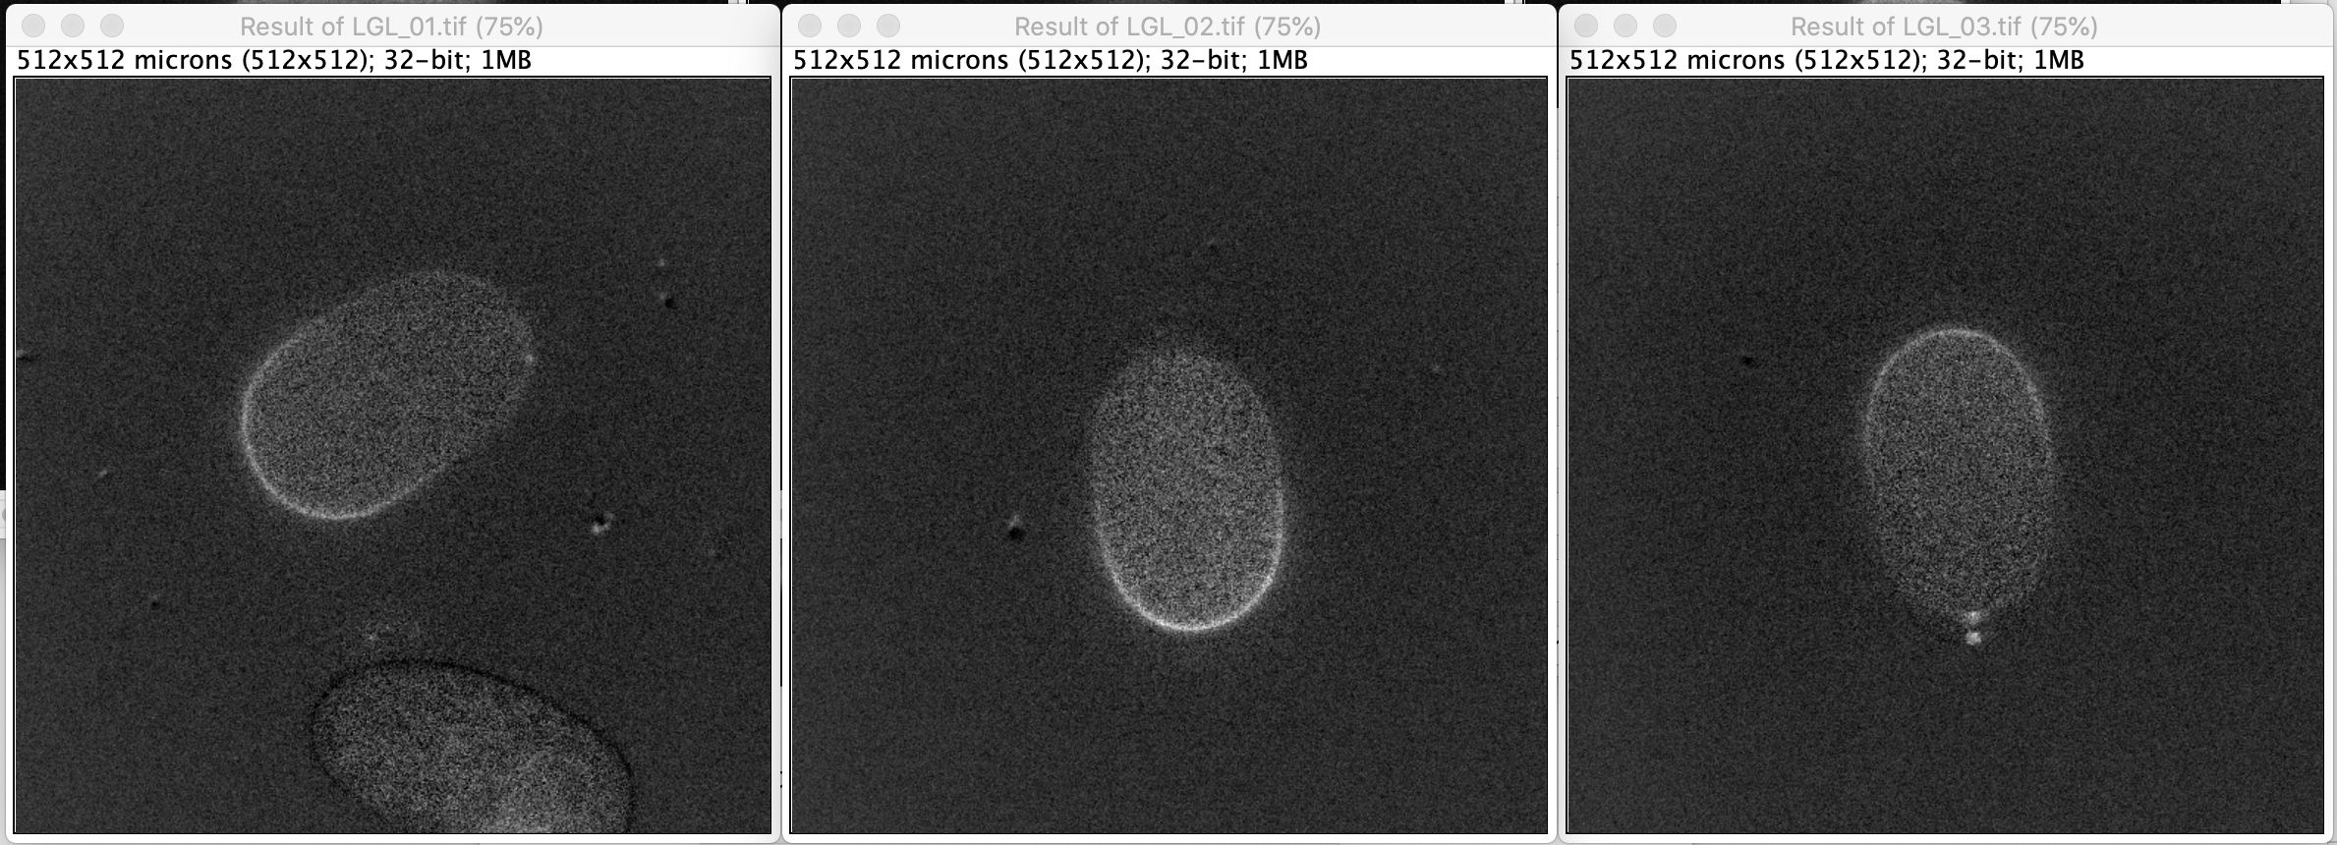

NOTE: the new images will be 32-bit, with an appropriate scaling factor to ensure that pixel values are in the same units as the original images. Please DO NOT convert images back to 16-bit in FIJI as this will change the scaling of the pixel values.

**Considerations in implementing SAIBR**

* **Channel selection** - While there is no need to restrict channel choice to the **Primary** and **Predictor** channels used in the manuscript, SAIBR does rely on a spectrally distinct channel to capture AF on a selective basis. For AF in the GFP channel, we have found that simply red-shifting the emission band is usually a good place to start.
* **Autofluorescence sources** - SAIBR is generally optimized to compensate for a single dominant AF source in one channel. In principle, one could correct for AF in two imaging channels, e.g. GFP and RFP. In this case, one would need to acquire four spectrally distinct channels, e.g. GFP, AFGFP, RFP, AFRFP. One could then process each fluorophore channel through SAIBR separately using the appropriate calibration images (GFP only for RFP channel and RFP only for GFP channel). However, we have not tested this as AF in *C. elegans* is typically low in the RFP channel.
* **Autofluorescence distribution** - The SAIBR plugin uses pixel variation in the calibration images to generate the regression and thus samples must have sufficient spatial variation in signal for SAIBR to be able to calculate an accurate correction function. The SAIBR plugin will therefore fail if AF is spatially uniform. In such cases, one can use embryo-to-embryo variation in AF to generate a suitable correction function (as described for Figure 1F of the paper).  In this case, one would normally correct for AF by globally subtracting a mean AF value from the image.
* **Calibration images** - We typically usually use 3-5 calibration images taken at the same time and under identical conditions as our labelled samples.  This ensures that we can confirm that the relationships are consistent across samples.  If these nicely overlay, it also provides a reasonably good sense of how well SAIBR will work. There are a few samples in which we have obtained calibration curves that are highly variable or there is no clear correlation, and these samples were generally not suitable for SAIBR.
* **Image time series** - As currently configured, SAIBR only reads in the selected image timepoint when processing calibration images.  Once the calibration is set, SAIBR will apply the correction function to all timepoints of a stack.
* **Sample specific notes** – See the GitHub readme.

**Citation**

This program is made available under a CC BY 4.0 licence. If you use this program as part of a publication, please cite the following reference:

Rodrigues, N.T.L., Bland, T., Borrego-Pinto, J., Ng, K., Hirani, N., Gu, Y., Foo, S., and Goehring, N.W. (2022). SAIBR: A simple, platform-independent method for spectral autofluorescence correction. BioRxiv 2022.01.19.476881.